**Section 9**

**DP 9.1:**

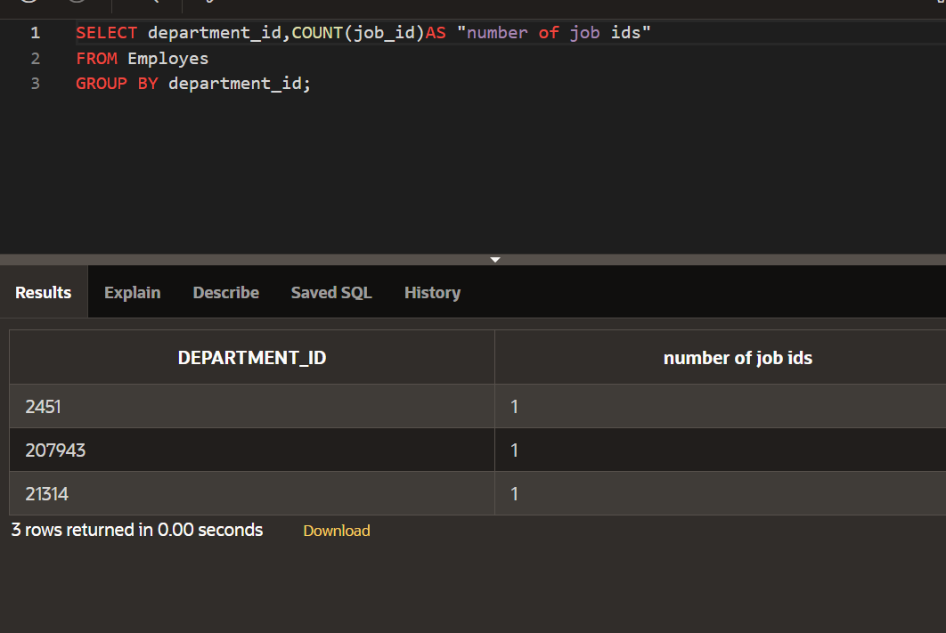

**DP 9.2:**

**DP 9.3:**



